Hurghada Hospital Management System (HHMS)
Project Management Plan
Course: Software Engineering Instructor: Dr. Wesam Ahmed Date: October 11, 2026
Seif Ahmed — Team Leader, Backend | Mohammed Mahmoud — Backend | Mohammed Hany — Frontend, Design
Moamen Mahmoud — Backend | Marwan Saber — Backend, Automation | Omar Essam — Testing / QA
Mohammed Ali — Backend | Patrick Hany — Frontend, Design | Ahmed Gamal — Testing / QA

1. Overview
We follow Scrum: thirteen one-week sprints from September 28 to December 25, 2026. New features stop on December 11, and the last two weeks are for testing, bug fixing and the final demonstration on December 25.

2. Team Organization
- Team leader: planning, coordination, code reviews and merging pull requests.
- Backend (5 members): API and database. Tasks are assigned at each sprint planning to balance the work; one member also owns the n8n automations.
- Frontend (2 members): app identity and all staff and patient screens.
- Testing (2 members): test cases, testing every feature, bug reports and progress tracking.

3. Planning
Every task is a card on our public Trello board (trello.com/b/mb3fqB6Y), moving through Backlog → Sprint → In Progress → Testing → Done. A card reaches Done only after it is tested. Each week starts with sprint planning, has short stand-ups, and ends with a review and retrospective.
Sprint | Dates | Goal | Status
1 | Sep 28 – Oct 4 | Data model, database schema, project setup, app identity | Completed
2 | Oct 5 – 11 | Accounts, login with JWT, user roles; login and sign-up screens | In progress
3 | Oct 12 – 18 | Admin: staff accounts, departments, doctors' working hours | Planned
4 | Oct 19 – 25 | Patients: sign-up, profile, walk-in registration, search | Planned
5 | Oct 26 – Nov 1 | Appointments: booking and cancellation | Planned
6 | Nov 2 – 8 | Doctor's schedule, patient check-in | Planned
7 | Nov 9 – 15 | Medical history | Planned
8 | Nov 16 – 22 | Prescriptions | Planned
9 | Nov 23 – 29 | Pharmacy: dispensing and stock | Planned
10 | Nov 30 – Dec 6 | Billing, n8n automations, screen polish | Planned
11 | Dec 7 – 11 | Integration and catch-up (feature freeze on Dec 11) | Planned
12 | Dec 12 – 18 | Testing, bug fixes, demo script and presentation | Planned
13 | Dec 19 – 25 | Final tests, rehearsal, documentation, final demo | Planned

4. Communication and Workflow
Tool | Used for | How often
WhatsApp | Quick coordination and stand-up updates | Daily
Discord | Sprint planning, review and retrospective calls; pairing on hard tasks | Weekly
GitHub | Code, pull requests and code reviews | Every task
Trello | Tasks, assignments, progress and bug reports | Daily

- One branch and one pull request per task, reviewed by the team leader before merging.
- One shared SQL Server database: passwords stay in local user secrets, never in the repository; one person runs migrations; only fake data is used.

5. Scheduling
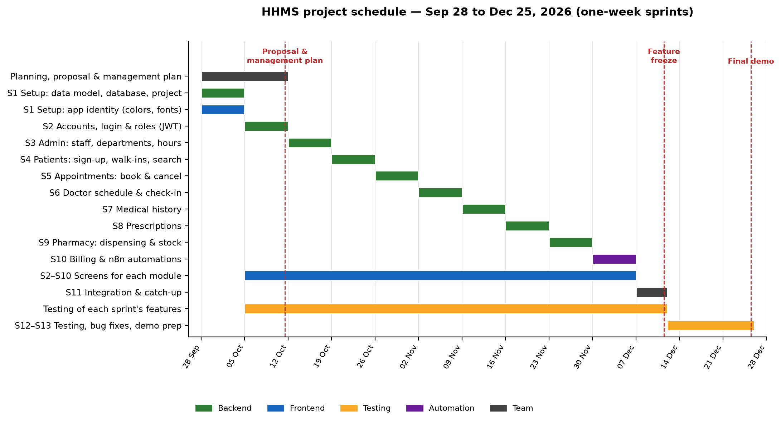
Milestones: database ready on Oct 4 (achieved) · proposal and plan on Oct 11 · feature freeze on Dec 11 · final demonstration on Dec 25.

6. Risk Management
We review these risks at every sprint retrospective.
Risk | Likelihood | Impact | How we reduce it
Inactive member or unequal workload | Medium | High | Small tasks assigned weekly; progress tracked on Trello; unfinished tasks reassigned
New technologies and frontend–backend integration | Medium | High | Setup sprint first; documented API; a dedicated integration sprint; pair work
Leaked credentials or exposed medical data | Medium | High | Secrets never committed; fake data; role checks on every request; row versioning
Merge conflicts | High | Medium | One branch per task; small pull requests; one person owns migrations
Scope creep | Medium | High | Fixed feature list; new ideas go to the backlog; freeze on Dec 11
Demo-day failure | Low | High | Two weeks of testing; rehearsal; runs locally with no deployment; backup recording

7. Quality and Documentation
- Testers test every feature before it reaches Done and report problems as Bug cards; Sprint 11 is a full end-to-end test of every role.
- The GitHub README is our live documentation (team, features, stack, database design, plan and contributions), with a separate guide to every database entity.
- A presentation and final documentation accompany the December 25 demonstration.

